Worked Examples - Squares up to 10x10 (IXL 3rd Grade P.15)

A **square number** is the product of a whole number times itself. Square numbers are sometimes called perfect squares. Any whole number raised to the power of two creates a square number!

Here are the square numbers up to 15!

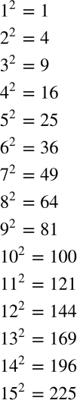

They are called square numbers because they represent the area of a square.

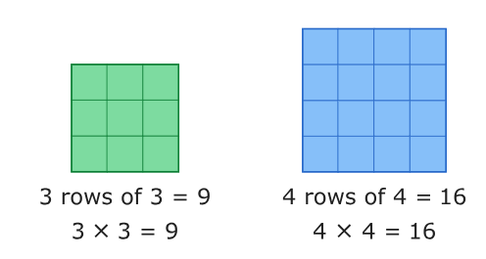

Try some practice problems, as knowing these by heart will help you in the upcoming unit.